# How Computers Are Used

Most people use a personal computer for daily activities such as communicating with others, writing letters or other documentation, calculating reports such as cash flow or budgets

# An Overview:

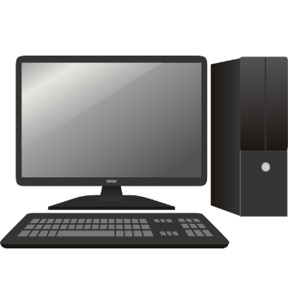

There are four elements that make up a personal computer system. The user, software, hardware and electricity all work together to form the whole system. Each element is crucial.In order for a computer to be able to store information the computer needs to have memory chips installed. Memory is measured in bytes.

# Looking at the Monitor

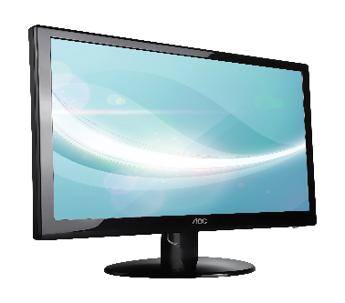

The Monitor is an output device, similar to a television set that allows you to view the information the computer displays.

# Using the Keyboard

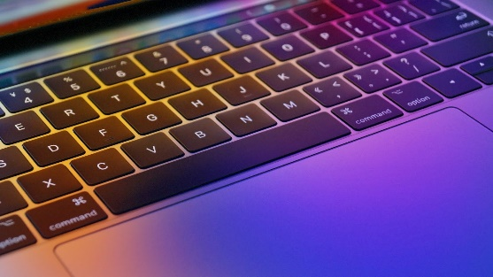

The Keyboard is an input device, similar to a typewriter, which allows you to send information to the computer.

# Using the Mouse

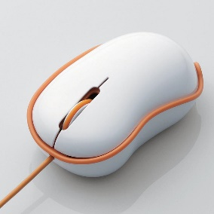

The mouse is a device used to move the mouse pointer around on the monitor.